Thought Leaders – A Book Summary by Brandon Yeager

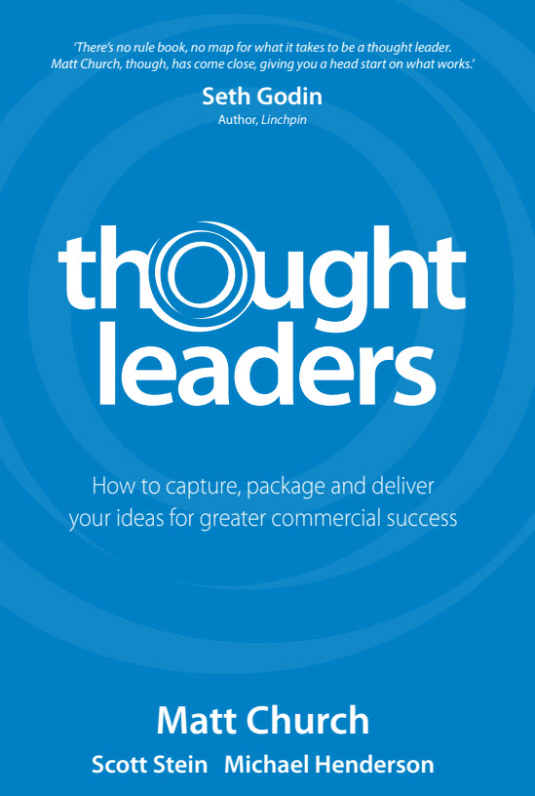

# About

## How to Capture, Package, and Deliver Your Ideas for Greater Commercial Success

## Authors: Matt Church, Scott Stein, Michael Henderson

## Preface by Matt Church

### The struggle to create clarity around a particular idea became his grand obsession.

### Not a book on capitalism, but rather a book on how clever people can be commercially smart with their ideas.

### Desire is to be able to capture great ideas, package them so the ideas do something great, that they get out into the world, and are so valued, that you get commercially rewarded for them.

## About Me

### BrandonYeager.com

### How You can Benefit the Most...Follow Along

# Thought Leaders Intro

## What is Thought Leadership?

### First coined in 1994 by Joel Kurtzman editor in chief of Strategy and Business magazine.

### A thought leader is a subject matter expert who has unique insights or perspectives to share in their area of expertise.

### Began by having questions asked of him:

* + - * + How do I learn to do what you do?
        + How do I construct my ideas in such a compelling and unique manner that positions me as a Thought Leader.

### Where do Thought Leaders Appear?

* + - * + Entrepreneurs

Build, grow, or leverage a commercial business

* + - * + Intrapreneurs

Works internally within an organization.

* + - * + Infopreneurs

Sells their ideas to others to assist them.

* + - * + Socialpreneur

Uses expertise to make a difference in social or community issues.

## Why TL? And Why NOW?

### Information in hands of all

### Business World has Changed

### Marketing has Changed-Forever!

### Increased Need to Innovate and Differentiate

# 9 Essential Skills of TL

## Uniqueness-Know who you are.

### Everybody is Unique...Combat Imposter Syndrome. (feeling fake or fraud). Many do not value their strengths/accomplishments.

* + - * + Finds Unpacking ideas...helps to overcome insecurities.
        + Discover Unique identity
        + Become less reliant on opinions of others.
        + Get clear/remind yourself of your purpose.

### Branding

* + - * + 3 Word Style Brand
        + Write profile for social media using the words

### 6 Step Process for Discovering Uniqueness

* + - * + Discovery - You are more than you think you are.
        + Vision - Design personal mantra for my vision.
        + Offering - Discover and define my unique strengths, talents, and expertise.
        + Experience - What do I bring to the table differently?
        + Presence - what is my signature presence?
        + Purpose - define core purpose and my story.

### Signature Style

* + - * + Being a Thought Leader is about Standing Out, not fitting in.
        + Spotlight on Peter Sheahan - Thought Leader for Businesses

## Expertise - unlocking and unpacking our IP

### Why Important?

* + - * + Big Challenge: crafting an idea into a format that allows TL's to quickly capture ideas and organize them in a way that somebody can quickly unpack the IP and consider ideas acrosss a full spectrum, and shuffle to be used in different ways.
        + Full Spectrum Ideas: crafting messages that dance through left-brain logic to right-brain creativity and from concrete examples to high level contextual thinking. Spectrum Model.
        + People are positioned as experts by their ability to capture expertise and share it with others.

### IP Snapshots - Pink Sheets

* + - * + Content - Specific

Left: Statistics, Case Studies, Step-by-Step guides.

Right: Stories, audience interviews

* + - * + Concept - Point Making

Summarize in 1 or 2 sentences

Formal

Casual

* + - * + Context - Big Picture

Models (left/logic)

Become a Model Kleptomaniac. Study anatomy, structure, design and intent.

RK's Cashflow quadrant

Maslows Hieracrhy

Metaphors(right/emotion)

Big Idea...object and activity based. Instruments. Transportation. Profession. Sports. Universe.

* + - * + Shoulders of Giants

Be obsessed with attribution.

My friend (Thought Leader) is an expert on (message) He created a brilliant framework called (name). I'd love to share it with you...

status/credibility increase

our creativity increases

they begin to share our ideas in exchange

We need to move from plagiarism to attribution

Q's to Ask

Who do I think?

yes...AND

yes...BUT

* + - * + 7 Step Process

Create List - things I know, talk on, or may like to share with others.

Clusters - idea has only a few points.

Have a point...this is the Concept.

Make it a Big Idea....diagram, metaphor.

Support point - facts, examples, stories, case studies.

Create a system - an Idea Bank...searchable and retrievable.

Customize Content...not Context.

## Perspective - See what is really going on.

### Become a Futurist...masters of perspective.

### Analyze with STEEP

* + - * + Social

age

culture

genders

pattens

* + - * + Technological

Speed

Cost

Innovations

Design

* + - * + Economic

Interest Rates

Inflation

Energy

Rate of economic growth

Employment

* + - * + Environmental

Legalizations

Shareholders

Information

Customers

* + - * + Political

Legislation

Government

Public services

Taxation

### WWJD?

* + - * + What would other people do?

## Positioning - share who you are...p.100

### So, what do you do?

* + - * + You - Dinner Party

Obsession - what lights you up.

Category - something they know.

History - edit out irrelvant bits.

* + - * + It - Networking Event

Uniqueness - what sets us apart?

Analogy - Something they already understand.

Example - Use Case Studies

* + - * + Them - Boardroom

Purpose - How you Help them achieve their purpose.

Problems

Solutions - some you prepared earlier.

## Delivery - Share what you know.

### Choosing your channel

* + - * + Tell - Content with stories and examples / Authorship
        + Show - Concepts with Ideas and Principles / Mentor
        + Ask - Context by asking Q's that elicit content /Coach

### 6 Main Channels

* + - * + Author
        + Mentor
        + Coach
        + Facilitator
        + Trainer
        + Speaker

## Adaptation - Adjust how you share ideas.

### Understanding Mindsets. p.139. Good ideas for various learning preferances.

* + - * + Visual

Posters

Banners

Images in PPTs

* + - * + Auditory

Music during breaks

Vary pitches while speaking

Soundbites - eg. Message Trumps Method.

* + - * + Kinesthetic

Something to Hold.

Interactive exercises.

Movement.

* + - * + Numerate

Number points.

Show of hands.

Ask audience to calculate.

* + - * + Linguistic

Formal set of words - environmental sustainability.

Only words we can pronounce.

language distinctions

* + - * + Interpersonal

For example...

Detailed case studies

Video interviews of others on topic.

* + - * + Abstract

Metaphors

Quotes/historical reference

Fables

* + - * + Existential

Relate principle to big ideas.

Create different ways of saying the same thing.

Introduce competing ideas...and shoot down.

* + - * + Intrapersonal

How can audience apply in their lives.

How we personally benefit.

Outline results.

## Execution - Becoming Massively Productive.

### Be Efficient

* + - * + Take notes
        + Mind mapping
        + Set Agendas

### Be Effective

* + - * + Most important task first
        + Say No
        + Manage interruptions

### Be Leveraged

* + - * + Recycle ideas.
        + Setup for future success...efficiency.
        + Tag, Store, and Recall

### Get Systematized

* + - * + Anything Repetitive...Systematize
        + SOP's
        + Habitual ways of performing.

### Be Functional

* + - * + Stay in Lane...no micromanaging.
        + Consistent accountability
        + Communications.

### Build Engagement

* + - * + Explain higher purpose of work.
        + Link tasks to drivers

### Get Active

* + - * + Create a bias for action.
        + Date and distribute tasks.
        + What decision are we making?

### Get Strategic

* + - * + Communicate big picture often
        + Know core activities and business
        + Say No.

### Get Aligned

* + - * + Builds culture.
        + Discuss values

## Clicking - Connecting your ideas.

### Dale Carnegie: People don't care how much you know till they know how much you care.

### Stop Selling...and Start letting people buy.

### Solutions is simple: Know the solution we propose, Know the clients problem, provide our stuff as the solution.

# Million Dollar Expert

## 1. Identify what we want.

## 2. Get Message clear.

## 3. Improve delivery method...practice.

## 4. Market - where are the opportunities.

## 5. Your Plan - Map plan forward.