Think

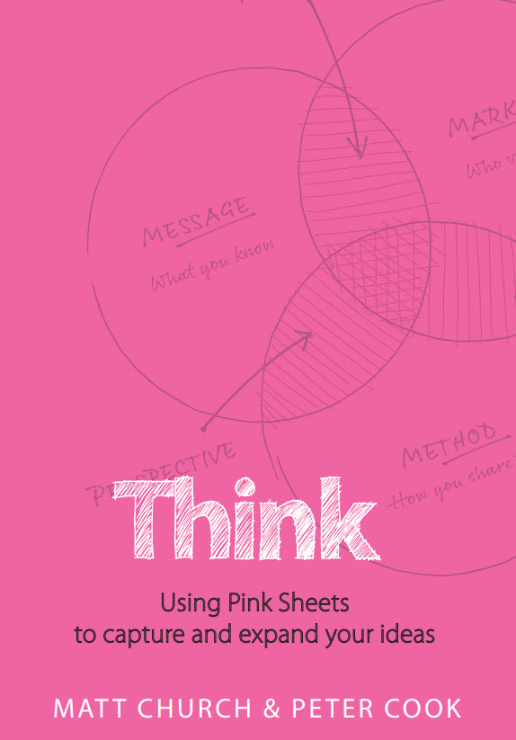

# About "Think"

## Using Pink Sheets to Capture and Expand Your Ideas

## Authors: Matt Church & Peter Cook

## About Me

### BrandonYeager.com

### Get the Most out of this Video

# Overview

## Part 1 - The Pink Sheets Process - Why, How, What

### Most Important Thing: Getting started with a pink sheet is more important than reading the whole book.

### What is a Pink Sheet?

* + - * + A tool used at TL to make an IP Snapshot.
        + It's a way of thinking deeply and deliberately about something.
        + Why called a pink sheet? That's what was in Matt's office printer at the time. :)

## Part 2 - Pink Sheet Examples

### Others

### Theirs

### 52 Examples

# Why They are So Important?

## Thinking conciously is the key...practice.

## Ways to expand your thinking...and structure it effectively.

## Benefits

### Conviction...you'll believe you are an expert.Will help you overcome imposter syndrome and thinking you aren't good enough.

### Commercial PhD

* + - * + 52 Pink sheets in an area of expertise.
        + Don't have to already be an expert in the field. Can become one....by learning and thinking deeply.

### Depth

* + - * + Pink sheets give depth of thinking and many angles to take the conversation.

### Gets it out of your head.

* + - * + If teacher, expert, or TL, knowledge and VALUE is in your head.
        + Brains are great for storage, but retrieval is sometimes an issue.
        + And the ideas to get organizized into a body of work.

### Think Once, Deliver Often.

* + - * + use again and again in different contexts.
        + Can be part of a speech, part of a book, training module, or coaching session.

## Full Spectrum Thinking - Aristotle -suggested you'll need all 3 to convince somebody of something.

### Logos

* + - * + Logical and rational.

### Pathos

* + - * + The emotional appeal

### Ethos

* + - * + Ethical appeal...character and credibility.

### Left side is logic and reason. Right side is creativity and relationships.

### Model 4 quadrants p. 14.

### Where we are in the 4 quadrants (we all favor one of them) is where we best learn from and also communicate from...and think everyone else does as well!

### We must abe able to mix logos and pathos.

# What is a Pink Sheet - An Overview

## CONTEXT

### Model

* + - * + Diagram where this idea lives.
        + Can be shared across many pink sheets.

### Metaphor

* + - * + Uses existing neural pathways and immediately apply in a new context.
        + Some metaphors can be shared on multiple pink sheets, others once.

## CONCEPT

### Statement

* + - * + The point...memorable and punchy.

### Explanation

## CONTENT

### Stats/Studies

* + - * + Supporting data, case studies

### Story

* + - * + Stories and anecdotes.

# Generating Ideas

## People want to hear from us. Our experiences. Our expertise.

### Want to have a notes app of some type for gathering, or a notebook...even incomplete and unrefined ones.

### There is no shame in building upon others work.

### Can use quotes to kickstart our thinking.

### 18th century German Philosopher Johann Wolfgang von Goethe said "Seldom should we let the urgent take the place of the important, but oftentimes we do". Dr. Stephen Covey used that to write First things First and built a TL empire on that.

## Elevating others, and honoring them, elevates ourselves.

### Student says..."That's a great idea"

### Teacher says..."Great idea, how do I share it"

### TL says..."Great idea, what do I think about that?

### Use "Yes, But", or "Yes, and" to flesh out thoughts.

### Many authors dewell in content...we may be the ones to pull it together into a contextual whole.

## How to Start

### Start anywhere...but when getting started...the middle Concept is a great place to start.

### Starting at the point...anytime I give advice, have an opinion, make a point, or have a Yes, but...we have an idea that needs a pink sheet.

* + - * + Once made oint, think about idea at a higher, more contextual level, graphically, or with an image. Then, think about a Metphor we can use for understanding.
        + Now, let's capture some evidence. back up our point with stats and stories that prove it.

### Model Behaviour

* + - * + When starting with a model, actually have an entire family of pink sheets.

Example...a 2X2 matrix, will have at least 7. 4 boxes, 2 axes, and overall concept.

### Content First.

* + - * + Can also start with creation with an interesting story or study we read...may not even know what the point is yet, but we like the story.

# Models - Top Left...Left Brain, Contextual tools.

## Magical...something profound happens.

### Many other sheets can be generated from well thought out model.

### Creates structure and frameworks.

### Primarily lines, shapes, circles, graphs. Conveys meaning and connections.

### Great Models

* + - * + Dr. Linda Hills Collective Genius is a venn diagram.
        + Dr Stephen Covey First things First is a quadrant.
        + Simon Sineks Start With Why is concentric cirlces.

## 4 Categories of Models

### Why

* + - * + Simple Ladder Model

Explain reasoning behind an idea. It's job is to communicate value. Currency could be Money (earning/saving), Time (saving), Status, or Happiness.

Location...where they currently are.

Aspiration...rung of the ladder they want to reach. We can help people get where they want to go.

### What

* + - * + 3X3 matrix

Prescriptions and tactical ideas of our thinking. It's the turn-by-turn directions.

Has a beginning and ending step...naming of rows and columns.

pathways should give warning signs...

### How

* + - * + Venn Diagram

All about the overview...creates awareness, provides distinctions...and prescriptive actions.

Intersections can come alive!

### If

* + - * + Contrast of 2 frames

Like a before and after weight loss picture.

past contrasted with future, good vs bad.

Can sometimes simply add a 3rd column to bridge the 2.

### Bernice McCarthy does a slightly different version in her 4MAT model.

# Metaphors - Top Right...Right Brain, Contextual Big Ideas

## Take up space in the mind and communicate massive amounts of meaning in short amount of time.

## The Power is the picture it creates in a person's mind...it's the Ultimate Trojan horse...see what they did there? ;)

### Most typically used like a wrestler would do their finishing move...they don't get you the win, but they are a perfect way to end a bout.

### As we become affluent in pink sheets, we'll see metaphors everywhere.

### When the model and metaphor are in alignment, the angels sing.

### They are a perfect final touch...they are the icing on the cake.

### The are a practice of their own within the pink sheeting process.

# Point - Key Idea that differentiate one sheet from another.

## One point. One sheet. Never can be duplicated.

## Goal of this section is to carefully select our words. Focus on the "poetry of our points"

## They are your book titles and blog post headings. In 100 years after we're gone, they may remain.

## 4 Main Ideation Strategies

### A/B Statement

* + - * + A Statement is the title of the book. 10 words at most, but probably less. Snappy and Memorable.

Speakership is Leadership

* + - * + B Statement carefully worded also. will or won't sell the book, or the idea, to someone.

Every time you speak in public you are auditioning for a leadership position.

### Make it a Mantra

* + - * + Create memorable phrasing.

### Left Brain / Right Brain

* + - * + Left Brain

Earn $500K per year working 50-200 days, with one or 2 support staff.

* + - * + Right Brain

Do work you love, with people you like, the way you want.

* + - * + Goal is to stretch the gap between the two statements.

### 7/17/37/70

* + - * + Pretend the age recipient

7: Speakership is leading out loud.

17: Speakership is leadership and every tribe needs a leader.

37: Stop Managing and Start Leading; stop informing and start inspiring.

70: Speakership is the missing link between strategy and execution, between wanting people to do something, and inspiring them to act.

# Case Studies/Stats - Lower Left Content

## Feel similar to stories, but aren't. Power piece of social proof.

### Case studies have 3 points, an incident, a point, and a benefit.

### Also, oftentimes case studies are more number and statistic centered.

### Supporting media, video, article, etc helps.

### Pictures are powerful and data conveys meaning.

# Stories - Lower Right - Content

## Don't write the entire story, just a title, or memory jogger goes there.

## don't tell your stories....act them out.

## 4 Types of Stories

### Icon's

* + - * + somebody we admire...gives us humility...and elevates us.
        + don't be the hero...tell me about one.

### Personal

* + - * + always try to deliver through humility
        + RDPD...puts the Rich Dad on a pedestal...not himself.

### Anecdotal

### Historical

* + - * + Matt uses Ancient rome a lot.

When Julius Caesar spoke, people wept

When Cicero spoke, armies marched.

# Pink Sheets 2.0

## 6 Additional Elements to Consider

### 1 Word

### Card Ranking...give a score of 1-10.

### Quotes - Memorize them. Show pictures of person. Interesting fact about the person.

### Learning Activity - embeds concepts.

### Infographic...sits on Content between case study and story. brings data and turns it into a visual display.

### 12 Questions - boardrooms, facilitating conversation...can be open ended, or direct people down a path to something else.

## Delivering Pink Sheets

### 3 Jobs for your practice, to Think, to Sell, and to Deliver.

### Speaker and Authors - tell stories, inspire, ask questions, share facts. if y ou want best sellers, share stories, anecdotes. and applied examples.

### Trainer and Mentor - show an idea. focus on concepts. Get to the point, stay on point, and don't move off until the audience gets

### Facilitator and Coach - Ask questions. focus on context.

### 6 Delivery Channels

* + - * + Tell Direct: Author
        + Show Direct: Mentor
        + Ask Direct: Coach
        + Tell Indirect: Speaker
        + Show Indirect: Trainer
        + Ask Indirect: Facilitator

# Part 2 - Examples: Demonstration and Analysis

## Famous Ideas

### Stephen Covey - First Things First

* + - * + All equal quadrants, or can be judgemental with one being better than others.

### Carol Dweck

* + - * + Fixed vs Growth Mindset...contrast between old vs new.

### Simon Sinek

* + - * + Start with Why

The Golden Circle...could have had a better metaphor.

Simple concentric circles.

## Some of Their Pink Sheets

### The Revenue Ladder

### The Cluster Strategy

### Business vs Practice

### Selling Thought Leadership

## Afterword by Pete

### Humble yourself in the process of pink sheeting. Think of yourself less, not less of yourself.

### Come from service to others, your pink sheets will instantly be better.

### Practice makes perfect.

### Empty your mind daily...Collect Your ideas.

### Helpful to think pink sheets come Through you, not from you.